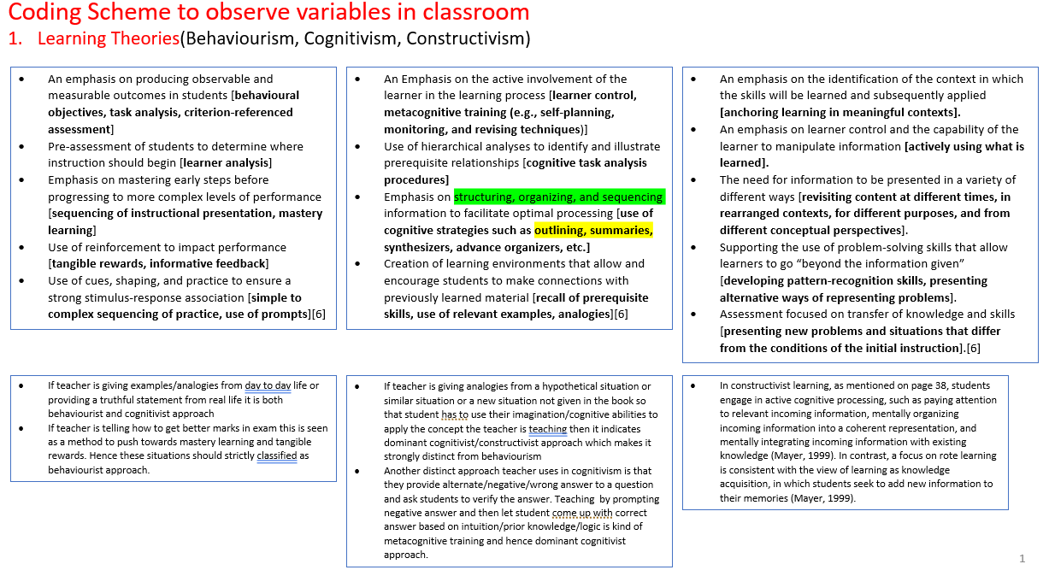
Operational Coding for Learning Theories
Fig 1
Behaviorism, Cognitivism, Constructivism: Comparing Critical Features From an Instructional Design Perspective” by P.A. Ertmer and T.J. Newby is reprinted from Performance Improvement Quarterly, 6(4), 1993, pp. 50–72. doi: 10.1111/j.1937- 8327.1993.tb00605.x

Side Note
Behaviourism
- Instructions application
  - Students complete assignments to avoid punishment/Not properly motivated
  - A second concern is that reinforcement occurs infrequently and often not at the proper time. Consequently, students may learn incorrectly, which means that teachers must spend additional time giving corrective feedback.
  - A third point is that the scope and sequence of curricula do not ensure that all students acquire skills. Students do not learn at the same pace.
- A behavioural objective describes what students do when demonstrating their achievements and how teachers know what students are doing (Mager, 1962). Four parts of a good objective are:
  - The specific group of students
  - The actual behaviours students are to perform as a consequence of instructional activities
  - The conditions or contexts in which the students are to perform the behaviours
  - The criteria for assessing student behaviours to determine whether objectives have been met
  - A sample objective with the parts identified is: Given eight addition problems with fractions of unlike denominators (3), the fourth-grade math student (1) will write the correct sums (2) for at least seven of them (4).
- Learning Time: Carroll (1963, 1965) formulated a model of school learning that places primary emphasis on the instructional variable of time spent learning. Students successfully learn to the extent that they spend the amount of time they need to learn. Time means academically engaged time, or time spent paying attention and trying to learn. Although time is an environmental (observable) variable, this definition is cognitive because it goes beyond a simple behavioural indicator of clock time.
- degree of learning = (time spent)/(time needed)
Ideally, students spend as much time as they need to learn (degree of learning 1.0), but learners typically spend either more time (degree of learning > 1.0) or less time (degree of learning < 1.0) than they require.
- Mastery Learning: Carroll’s model predicts that if students vary in aptitude for learning a subject and if all receive the same amount and type of instruction, their achievement will differ. If the amount and type of instruction vary depending on individual differences among learners, then each student has the potential to demonstrate mastery; the positive relation between aptitude and achievement will disappear because all students will demonstrate equal achievement regardless of aptitude.
- At the outset of teaching for mastery, teachers orient students to the mastery procedures and provide instruction using the entire class, small groups, or individual seat work activities. Teachers give the formative test and certify which students achieve mastery. Students who fall short might work in small groups reviewing troublesome material, often with the aid of peer tutors who have mastered the material. Teachers allow students time to work on remedial materials along with homework. Grading for mastery includes a summative (end-of-course) test. Students who score at or above the course mastery performance level receive A grades; lower scores are graded accordingly.
- A mastery learning approach can be beneficial in certain learning environments. For example, in a remedial reading group for secondary students, a well-organised mastery learning program would allow students to progress at their own rates. Students motivated to make rapid progress are not slowed down by this type of instruction, as might happen if they are placed in a traditional learning format. A key requirement is to include a progression of activities from easier to more difficult. The program should have checkpoints at which the students interact with the teacher so that their progress is evaluated, and reteaching or special assistance is provided if needed. Young children enter school with a wide range of experiences and abilities. Mastery learning can help teachers deal effectively with varying abilities and developmental levels. Mastery learning techniques can be implemented by using learning centres and small groups. Children can be placed in different centres and groups according to their current levels. Then, they can move through the various levels at their own rates.
- Programmed Instruction: Programmed instruction (PI) refers to instructional materials developed in accordance with operant conditioning principles of learning (O’Day, Kulhavy, Anderson, & Malczynski, 1971).
- Contingency Contracts: A contingency contract is an agreement between teacher and student specifying what work the student will accomplish and the expected outcome (reinforcement) for successful performance (Homme, Csanyi, Gonzales, & Rechs, 1970). A contract can be made verbally, although it usually is written. Teachers can devise the contract and ask if the student agrees with it, but it is customary for the teacher and the student to formulate it jointly.

What Are the Implications for Instruction?
Learning requires establishing responses to discriminative stimuli. Practice is needed to strengthen responses. Complex skills can be established by shaping progressive, small approximations of the desired behaviour. Instruction should have clear, measurable objectives, proceed in small steps, and deliver reinforcement. Mastery learning, computer-based instruction, and contingency contracts are useful ways to promote learning.

Cognitivism
Teaching for Consolidation
Factors such as organisation, rehearsal, and elaboration help the brain impose structure on learning and assist in the consolidation of neural connections in memory. Teachers can incorporate these ideas in various ways.
Organisation
Ms. Standar’s students are studying the American Revolution. Rather than ask them to learn many dates, she creates a timeline of key events and explains how each event led to subsequent events. Thus, she helps students chronologically organise the key events by relating them to events that they helped to cause.
In her high school statistics course, Ms. Conwell organises information about normally distributed data using the normal curve. On the curve, she labels the mean and the standard deviations above and below the mean. She also labels the percentages of the area under portions of the curve so students can relate the mean and standard deviations to the percentages of the distribution. Using this visual organiser is more meaningful to students than written information explaining these points.
Rehearsal
Mr. Luongo’s elementary students will perform a Thanksgiving skit for parents. Students must learn their lines and also their movements. He breaks the skit into subparts and works on one part each day, then gradually merges the parts into a longer sequence. Students thus get plenty of rehearsal, including several rehearsals of the entire skit.
Mr. Gomez has his ninth-grade English students rehearse with their vocabulary words. For each word list, students write the word and the definition and then write a sentence using the word. Students also write short essays every week, in which they try to incorporate at least five vocabulary words they have studied this year. This rehearsal helps to build memory networks with word spellings, meanings, and usage.

Elaboration
Elaboration is the process of expanding information to make it meaningful. Elaboration can help to build memory networks and link them with other relevant ones.
Mr. Jackson knows that students find precalculus difficult to link with other knowledge. Mr. Jackson surveys his students to determine their interests and what other courses they are taking. Then, he relates precalculus concepts to these interests and courses. For example, for students taking physics, he links principles of motion and gravity to conic sections (e.g., parabolas) and quadratic equations.
Ms. Kay’s middle school students periodically work on a unit involving critical thinking on issues of personal responsibility. Students read vignettes and then discuss them. Rather than letting them simply agree or disagree with the story character’s choices, she forces them to elaborate by addressing questions such as: How did this choice affect other people? What might have been the consequences if the character had made a different choice? What would you have done and why?
Schunk, Dale H. Learning theories: an educational perspective / Dale H. Schunk.—6th ed. pp 47-48

Advance Organizers
Advance organisers are broad statements presented at the outset of lessons that help to connect new material with prior learning (Mayer, 1984). Organisers direct learners’ attention to important concepts to be learned, highlight relationships among ideas, and link new material to what students know (Faw & Waller, 1976).
Organisers can be expository or comparative.
Expository organisers provide students with new knowledge needed to comprehend the lesson. Expository organisers include concept definitions and generalisations.
Concept definitions state the concept, a superordinate concept, and the characteristics of the concept. In presenting the concept of a “warm-blooded animal,” a teacher might define it (i.e., an animal whose internal body temperature remains relatively constant), relate it to superordinate concepts (animal kingdom), and give its characteristics (birds, mammals).
Generalisations are broad statements of general principles from which hypotheses or specific ideas are drawn. A generalisation appropriate for the study of terrain would be: “Less vegetation grows at higher elevations.” Teachers can present examples of generalisations and ask students to think of others.
Comparative organisers introduce new material by drawing analogies with familiar material. Comparative organisers activate and link networks in LTM. If a teacher were giving a unit on the body’s circulatory system to students who have studied communication systems, the teacher might relate the circulatory and communication systems with relevant concepts such as the source, medium, and target. For comparative organisers to be effective, students must have a good understanding of the material used as the basis for the analogy.
Advance organisers help students connect new material with prior learning.
Kathy Stone is teaching her students to develop comprehensive paragraphs. The students have been learning to write descriptive and interesting sentences. Mrs. Stone writes the students’ sentences on the board and uses them as an organiser to show how to put sentences together to create a complete paragraph.
A middle school teacher might employ an organiser during geography. The teacher might begin a lesson on landforms (surfaces with characteristic shapes and compositions) by reviewing the definition and components of the geography concepts previously discussed. The teacher wants to show that geography includes elements of the physical environment, human beings and the physical environment, and different world regions and their ability to support human beings. To do this, the teacher initially could focus on elements of the physical environment and then move to landforms. The teacher then might discuss types of landforms (e.g., plateaus, mountains, hills) by showing mock-ups and asking students to identify key features of each landform. This approach gives students an overall framework or outline into which they can integrate new knowledge about the components.
In medical school, an instructor teaching the effects of blood disorders might begin by reviewing the basic parts of blood (e.g., plasma, white and red cells, platelets). Then, the teacher could list various categories of blood disease (e.g., anaemia, bleeding and bruising, leukaemia, bone marrow disease). The students can build on this outline by exploring the diseases in the different categories and by studying the symptoms and treatments for each condition.

Attention
Attention is a limited resource; learners do not have unlimited amounts of it. Learners allocate attention to activities as a function of motivation and self-regulation (Kanfer & Ackerman, 1989; Kanfer & Kanfer, 1991)
Various practices help keep classrooms from becoming predictable and repetitive, which decreases attention. Teachers can vary their presentations, materials used, student activities, and personal qualities such as dress and mannerisms. Lesson formats for young children should be kept short. Teachers can sustain a high level of activity through student involvement and by moving about to check on student progress.
Kathy Stone might include the following activities in a language arts lesson in her third-grade class. As students begin each section of a teacher-directed exercise, they can point to the location on their papers or in their books. The way sections are introduced can be varied: Students can read together in small groups, individual students can read and be called on to explain, or she can introduce the section. The way students’ answers are checked can also be varied: Students can use hand signals or respond in unison, or individual students can answer and explain their answers. As students independently complete the exercise, she moves about the room, checks students’ progress, and assists those having difficulty learning or maintaining task focus.
Table 5.1 Suggestions for focusing and maintaining student attention.

Device | Implementation
Signals | Signal to students at the start of lessons or when they are to change activities.
Movement | Move while presenting material to the whole class. Move around the room while students are engaged in seat work.
Variety | Use different materials and teaching aids. Use gestures. Do not speak in a monotone.
Interest | Introduce lessons with stimulating material. Appeal to students’ interests at other times during the lesson.
Questions | Ask students to explain a point in their own words. Stress that they are responsible for their own learning.

Encoding
Encoding is the process of putting new (incoming) information into the information processing system and preparing it for storage in LTM. Encoding is usually accomplished by making new information meaningful and integrating it with known information in LTM. Important factors that influence encoding are organisation, elaboration, and schema structures.
Organisation
Gestalt theory and research showed that well-organized material is easier to learn and recall (Katona, 1940). Miller (1956) argued that learning is enhanced by classifying and grouping bits of information into organised chunks.
One way to organise material is to use a hierarchy into which pieces of information are integrated. Figure 5.5 shows a sample hierarchy for animals. The animal kingdom as a whole is on top, and underneath are the major categories (e.g., mammals, birds, reptiles). Individual species are found on the next level, followed by breeds. Other ways of organising information include the use of mnemonic techniques and mental imagery. Mnemonics enable learners to enrich or elaborate material, such as by forming the first letters of words to be learned into an acronym, familiar phrase, or sentence (Matlin, 2009). Some mnemonic techniques employ imagery; in remembering two words (e.g., honey and bread), one might imagine them interacting with each other (honey on bread). Using audiovisuals in instruction can improve students’ imagery.
Elaboration
Elaboration is the process of expanding upon new information by adding to it or linking it to what one knows. Elaborations assist encoding and retrieval because they link the to-be-remembered information with other knowledge. Rehearsing information keeps it in WM but does not necessarily elaborate on it. A distinction can be drawn between maintenance rehearsal (repeating information over and over) and elaborative rehearsal (relating the information to something already known). Students learning U.S. history can simply repeat “D-Day was June 6, 1944,” or they can elaborate it by relating it to something they know (e.g., in 1944, Roosevelt was elected president for the fourth time). Mnemonic devices elaborate information in different ways. Once such a device is to form the first letters into a meaningful sentence. For example, to remember the order of the planets from the sun, you might learn the sentence, “My very educated mother just served us nine pizzas,” in which the first letters correspond to those of the planets Mercury, Venus, Earth, Mars, Jupiter, Saturn, Uranus, Neptune, Pluto). You first recall the sentence and then reconstruct the planetary order based on the first letters. Students may be able to devise elaborations, but if they cannot, they do not need to labour needlessly when teachers can provide effective elaborations. To assist storage in memory and retrieval, elaborations must make sense. Elaborations that are too unusual may not be remembered. Precise, sensible elaborations facilitate memory and recall (Bransford et al., 1982; Stein, Littlefield, Bransford, & Persampieri, 1984).
Schemas
A schema (plural schemas or schemata) is a structure that organises large amounts of information into a meaningful system. Schemas include our generalised knowledge about situations (Matlin, 2009). Common educational schemas involve laboratory procedures, studying, and comprehending stories. When given material to read, students activate the type of schema they believe is required. If students are to read a passage and answer questions about the main ideas, they may periodically stop and quiz themselves on what they believe are the main points (Resnick, 1985). Schemas have been used extensively in research on reading and writing (McVee, Dunsmore, & Gavelek, 2005).
Marshall might teach his students to use a schema to locate factual answers to questions listed at the end of the chapter:
- Read through all of the questions.
- Read the chapter completely once.
- Reread the questions.
- Reread the chapter slowly and use paper markers if you find a section that seems to fit with one of the questions.
- Go back and match each question with an answer.
- When you find the answer, write it and the question on your paper.
- If you cannot find an answer, use your index to locate keywords in the question.
- If you still cannot locate the answer, ask Mr. Marshall for help.
Schunk, Dale H. Learning theories: an educational perspective / Dale H. Schunk.—6th ed. pp 47-48

Constructivism
The history of learning theory reveals a shift away from environmental influences and toward human factors as explanations for learning. The advent of cognitive psychology disputed the claim of behaviourism that stimuli, responses, and consequences were adequate to explain learning. Cognitive theories place great emphasis on learners’ information processing as a central cause of learning. Despite the elegance of cognitive learning theories, some researchers believe that these theories fail to capture the complexity of human learning. Today, a number of learning researchers have shifted even more toward a focus on learners. Rather than talk about how knowledge is acquired, they speak of how it is constructed. Although these researchers differ in their emphasis on factors that affect learning and learners’ cognitive processes, the theoretical perspectives they espouse may be loosely grouped and referred to as constructivism.
CONSTRUCTIVISM: ASSUMPTIONS AND PERSPECTIVES
Many researchers and practitioners question some of cognitive psychology’s assumptions about learning and instruction because they believe that these assumptions do not completely explain students’ learning and understanding. These questionable assumptions are as follows (Greeno, 1989):
- Thinking resides in the mind rather than in interaction with persons and situations.
- Processes of learning and thinking are relatively uniform across persons, and some situations foster higher-order thinking better than others.
- Thinking derives from knowledge and skills developed in formal instructional settings more than from general conceptual competencies that result from one’s experiences and innate abilities.
Constructivists do not accept these assumptions because of evidence that thinking takes place in situations and that cognitions are largely constructed by individuals as a function of their experiences in these situations (Bredo, 1997).
What Is Constructivism? Unlike other theories discussed in this text, there is a lack of consistency in the meaning of constructivism (Harlow, Cummings, & Aberasturi, 2006). Strictly speaking, constructivism is not a theory but rather an epistemology, or philosophical explanation about the nature of learning (Hyslop-Margison & Strobel, 2008; Simpson, 2002). A theory is a scientifically valid explanation for learning. Theories allow for hypotheses to be generated and tested. Constructivism does not propound that learning principles exist and are to be discovered and tested, but rather that learners create their own learning. Constructivist theorists reject the notion that scientific truths exist and await discovery and verification. A person’s constructions are true to that person but not necessarily to anyone else. This is because people produce knowledge based on their beliefs and experiences in situations (Cobb & Bowers, 1999), which differ from person to person. All knowledge, then, is subjective and personal and a product of our cognitions (Simpson, 2002). Learning is situated in contexts (Bredo, 2006).
Assumptions.
- Constructivism highlights the interaction of persons and situations in the acquisition and refinement of skills and knowledge (Cobb & Bowers, 1999).
- Constructivism contrasts with conditioning theories that stress the influence of the environment on the person, as well as with information processing theories that place the locus of learning within the mind with little attention to the context in which it occurs. It shares with social cognitive theory the assumption that persons, behaviours, and environments interact in a reciprocal fashion (Bandura, 1986, 1997).
- A key assumption of constructivism is that people are active learners and develop knowledge for themselves (Geary, 1995).
- To understand the material well, learners must discover the basic principles.
- Constructivists differ in the extent to which they ascribe this function entirely to learners. Some believe that mental structures come to reflect reality, whereas others (radical constructivists) believe that the individual’s mental world is the only reality.
- Constructivists also differ in how much they ascribe the construction of knowledge to social interactions with teachers, peers, parents, and others (Bredo, 1997)
- Another constructivist assumption is that teachers should not teach in the traditional sense of delivering instruction to a group of students. Rather, they should structure situations such that learners become actively involved with the content through the manipulation of materials and social interaction.
- Activities include
  - Observing phenomena, collecting data, generating and testing hypotheses, and working collaboratively with others.
  - Classes visit sites outside of the classroom.
  - Teachers from different disciplines plan the curriculum together.
  - Students are taught to be self-regulated and take an active role in their learning by setting goals, monitoring and evaluating progress, and going beyond basic requirements by exploring interests (Bruning et al., 2004; Geary, 1995).
Constructivism has important implications for instruction and curriculum design (Phillips, 1995).
- The most straightforward recommendations are to involve students actively in their learning and to provide experiences that challenge their thinking and force them to rearrange their beliefs.
- Constructivism also underlies the current emphasis on reflective teaching
Constructivism and Teaching
- During a first-grade math lesson on measurement and equivalency, children were asked to use a balance to determine how many plastic links equal one metal washer in weight. The teacher recognised and seized an opportunity to help one particularly eager child, Anna, begin to construct a rudimentary notion of ratio and proportion.
Teacher: How many links does it take to balance one washer?
Anna: (After a few seconds of experimenting) Four.
Teacher: If I placed one more washer on this side, how many more links do you think we would need to balance it?
Anna: One.
Teacher: Try it.
Anna placed one more link in the balance tray and noticed that the balance was not achieved. She looked confused and placed another link in the tray and then a third. Still no balance. She placed one more link in the tray. Balance was achieved. She smiled and looked at the teacher.
Teacher: How many cubes did it take to balance one washer?
Anna: Four.
Teacher: And how many to balance two washers?
Anna: (Counting) Eight.
Teacher: If I put one more washer on this side, how many more links will you need to balance it?
Anna: (Pondered and looked quizzically at the teacher) Four.
Teacher: Try it.
Anna: (After successfully balancing with four links) Each washer is the same as four links.
Teacher: Now, let me give you a really hard question. If I took four links off of the balance, how many washers would I need to take off in order to balance it?
Anna: One!
(Brooks & Brooks, 1999, p. 73)

- Constructivism emphasises integrated curricula and having teachers use materials in such a way that learners become actively involved.
Kathy Stone implements various constructivist ideas in her third-grade classroom using integrated units. In the fall, she presents a unit on pumpkins. In social studies, children learn where pumpkins are grown and about the products made from pumpkins. They also study the uses of pumpkins in history and the benefits of pumpkins to early settlers. Kathy takes her class on a field trip to a pumpkin farm, where they learn how pumpkins are grown. Each student selects a pumpkin and brings it back to class. The pumpkin becomes a valuable learning tool. In mathematics, the students estimate the size and weight of their pumpkins and then measure and weigh them. They establish class graphs by comparing all the pumpkins by size, weight, shape, and colour. The children also estimate the number of seeds they think Kathy Stone’s pumpkin has, and then they count the seeds when she cuts open her pumpkin. As another class activity, the students make pumpkin bread with their pumpkins. For art, they design a shape for the carving of their pumpkins, and then, with Kathy’s assistance, they carve them. In language arts, they write a story about pumpkins. They also write a thank-you letter to the pumpkin farm. For spelling, Kathy uses words that they have used in the study of pumpkins. These examples illustrate how she integrates the study of pumpkins across the curriculum.
Constructivist learning environments
Key Features
- Learning in a constructivist setting does not mean allowing students to do whatever they want. Rather, constructivist environments should create rich experiences that encourage learning.
- Constructivist classrooms differ from traditional classrooms in several ways (Brooks & Brooks, 1999). In traditional classes, basic skills are emphasised. The curriculum is presented in small parts using textbooks and workbooks. Teachers disseminate information to students didactically and seek correct answers to questions. Assessment of student learning is distinct from teaching and usually done through testing. Students often work alone.
- In constructivist classrooms, the curriculum focuses on big concepts. Activities typically involve primary sources of data and manipulative materials. Teachers interact with students by seeking their questions and points of view. Assessment is authentic; it is interwoven with teaching and includes teacher observations and student portfolios. Students often work in groups. The key is to structure the learning environment such that students can effectively construct new knowledge and skills (Schuh, 2003).
- Guiding principles of constructivist learning environments.
  - Pose problems of emerging relevance to students. (Brooks & Brooks, 1999)
  - Structure learning around primary concepts.
  - Seek and value students’ points of view.
  - Adapt curriculum to address students’ suppositions.
  - Assess student learning in the context of teaching.
- One principle is that teachers should pose problems of emerging relevance to students, where relevance is preexisting or emerges through teacher mediation. Thus, a teacher might structure a lesson around questions that challenge students’ preconceptions. This takes time, which means that other critical content may not be covered. Relevance is not established by threatening to test students, but rather by stimulating their interest and helping them discover how the problem affects their lives.
- A second principle is that learning should be structured around primary concepts. This means that teachers design activities around conceptual clusters of questions and problems so that ideas are presented holistically rather than in isolation (Brooks & Brooks, 1999). A piecemeal approach to teaching history is to present information chronologically as a series of events. In contrast, a holistic method involves presenting themes that recur in history (e.g., economic hardships, disputes over territory) and structuring content so that students can discover these themes in different eras. Students then can see that although environmental features change over time (e.g., armies → air forces, farming →, technology), the themes remain the same.
- Third, it is important to seek and value students’ points of view. Understanding students’ perspectives is essential for planning activities that are challenging and interesting. This requires that teachers ask questions, stimulate discussions, and listen to what students say. Teachers who make little effort to understand what students think fail to capitalise on the role of their experiences in learning. This is not to suggest that teachers should analyse every student's utterance; that is not necessary, nor is there time to do it. Rather, teachers should try to learn students’ conceptions of a topic. With the current emphasis on achievement test scores, it is easy to focus only on students' correct answers. Constructivist education, however, requires that—where feasible—we go beyond the answer and learn how the students arrived at that answer. Teachers do this by asking students to elaborate on their answers; for example, “How did you arrive at that answer?” or “Why do you think that?”
- Fourth, we should adapt the curriculum to address students’ suppositions. This means that curricular demands on students should align with the beliefs they bring to the classroom. When there is a gross mismatch, lessons will lack meaning for students. But alignment need not be perfect. Demands that are slightly above students’ present capabilities (i.e., within the zone of proximal development) produce challenges and learning. When students’ suppositions are incorrect, the typical response is to inform them of such. Instead, constructivist teaching challenges students to discover the information. Recall the opening scenario describing a first-grade lesson on measurement and equivalence. Children were using a balance to determine how many plastic links equalled one metal washer in weight (Brooks & Brooks, 1999). This example shows how the teacher modified the lesson based on Anna’s suppositions and how she challenged Anna to discover the correct principle. Even after Anna answered “four” correctly, the teacher did not respond by saying “correct” but rather continued to question her.
- Finally, constructivist education requires that we assess student learning in the context of teaching. This point runs counter to the typical classroom situation where most learning assessments are disconnected from teaching, for example, end-of-grade tests, end-of-unit exams, and pop quizzes. Although the content of these assessments may align well with learning objectives addressed during instruction, the assessment occasions are separate from teaching. In a constructivist environment, assessment occurs continuously during teaching and is an assessment of both students and teachers. Anna’s learning was being assessed throughout the sequence, as was the success of the teacher in designing an activity and guiding Anna to understand the concept. Of course, assessment methods must reflect the type of learning (Chapter 1).
- Constructivist environments are best designed for meaningful, deep-structure learning, not for superficial understanding. True-false and multiple-choice tests may be inappropriate to assess learning outcomes.
- Authentic forms of assessment may require students to write reflective pieces, discussing what they learned and why this knowledge is useful in the world, or to demonstrate and apply skills they have acquired.
- Constructivist assessment is less concerned about right and wrong answers than about the next steps after students answer. This type of authentic assessment guides instructional decisions, but it is difficult because it forces teachers to design activities that elicit student feedback and then alter instruction as needed.

INSTRUCTIONAL APPLICATIONS
Discovery Learning
The Process of Discovery. Discovery learning refers to obtaining knowledge for oneself (Bruner, 1961). Discovery involves constructing and testing hypotheses rather than simply reading or listening to teacher presentations. Discovery is a type of inductive reasoning because students move from studying specific examples to formulating general rules, concepts, and principles. Discovery learning is also referred to as problem-based, inquiry, experiential, and constructivist learning (Kirschner et al., 2006).
Discovery is a form of problem-solving (Klahr & Simon, 1999; Chapter 7); it is not simply letting students do what they want. Although discovery is a minimally guided instructional approach, it involves direction; teachers arrange activities in which students search, manipulate, explore, and investigate. The opening scenario (Anna-teacher) represents a discovery situation. Students learn new knowledge relevant to the domain and such general problem-solving skills as formulating rules, testing hypotheses, and gathering information (Bruner, 1961).
To discover knowledge, students require background preparation (the well-prepared mind requires declarative, procedural, and conditional knowledge; Chapter 5). Once students possess prerequisite knowledge, careful structuring of the material allows them to discover important principles
Teaching for Discovery
- Teaching for discovery requires presenting questions, problems, or puzzling situations to resolve and encouraging learners to make intuitive guesses when they are uncertain. In leading a class discussion, teachers could ask questions that have no readily available answers and tell students that their answers will not be graded, which forces students to construct their own understandings. Discoveries are not limited to activities within the school.
- During a unit on ecology, students could discover why animals of a given species live in certain areas and not in others. Students might seek answers in classroom workstations, in the school media centre, and on or off the school grounds. Teachers provide structure by posing questions and giving suggestions on how to search for answers. A greater teacher structure is beneficial when students are not familiar with the discovery procedure or require extensive background knowledge.
- Learning becomes more meaningful when students explore their learning environments rather than listen passively to teachers.
- Kathy Stone uses guided discovery to help her third-grade children learn animal groups (e.g., mammals, birds, reptiles). Rather than providing students with the basic animal groups and examples for each, she asks students to provide the names of the types of animals. Then, she helps students classify the animals by examining their similarities and differences. Category labels are assigned once classifications are made. This approach is guided to ensure that classifications are proper, but students are active contributors as they discover the similarities and differences among animals.
- A high school chemistry teacher might use “mystery” liquids and have students discover the elements in each. The students could proceed through a series of tests designed to determine if certain substances are present in a sample. By using the experimental process, students learn about the reactions of substances to certain chemicals and also how to determine the contents of their substances.
- Gina Brown uses other problem-based learning activities in her class. She creates different classroom scenarios that describe situations involving student learning and behaviours as well as teacher actions. She divides her educational psychology students into small groups and asks them to work through each scenario and discover which learning principles best describe the situations presented.
- Discovery is not appropriate for all types of learning. Discovery can impede learning when students have no prior experience with the material or background information (Tuovinen & Sweller, 1999). Teaching for discovery learning may not be appropriate with well-structured content that is easily presented. Students could discover which historical events occurred in which years, but this is trivial learning.
- In deciding whether to use discovery, teachers should take into account the learning objectives (e.g., acquire knowledge or learn problem-solving skills), time available, and cognitive capacities of the students.
Inquiry Teaching
- Inquiry teaching is a form of discovery learning, although it can be structured to have greater teacher direction. Collins (1977; Collins & Stevens, 1983) formulated an inquiry model based on the Socratic teaching method. The goals are to have students reason, derive general principles, and apply them to new situations. Appropriate learning outcomes include formulating and testing hypotheses, differentiating necessary from sufficient conditions, making predictions, and determining when making predictions requires more information.
- In implementing the model, the teacher repeatedly questions the student. Questions are guided by rules such as “Ask about a known case,” “Pick a counterexample for an insufficient factor,” “Pose a misleading question,” and “Question a prediction made without enough information” (Collins, 1977).
Peer-Assisted Learning
Peer-assisted learning refers to instructional approaches in which peers serve as active agents in the learning process (Rohrbeck et al., 2003). Methods emphasising peer-assisted learning include peer tutoring, reciprocal teaching, and cooperative learning (covered in this section) (Palincsar & Brown, 1984; Slavin, 1995; Strain et al., 1981).
Discussions and Debates
Class discussions are useful when the objective is to acquire greater conceptual understanding or multiple sides of a topic. The topic being discussed is one for which there is no clear right answer, but rather involves a complex or controversial issue. Students enter the discussion with some knowledge of the topic and are expected to gain understanding as a result of the discussion. A variation of the discussion is the debate, in which students selectively argue sides of an issue. This requires preparation by the groups and, likely, some practice if they will be giving short presentations on their sides. Teachers enforce the rules of the debate and ensure that all team members participate. A larger discussion with the class can follow, which allows for points to be reinforced or new points brought up.

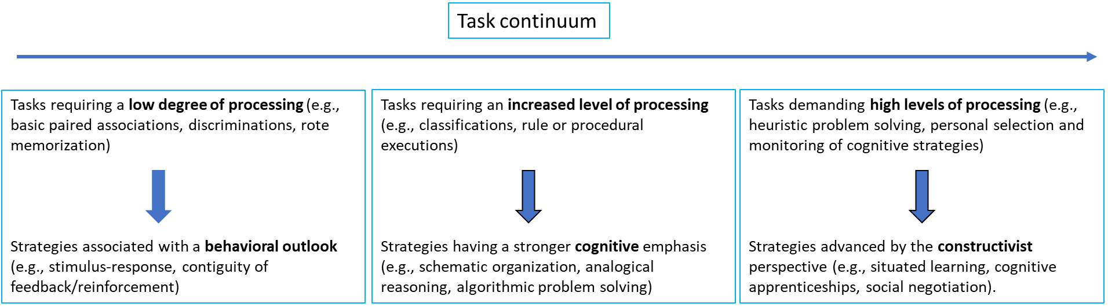
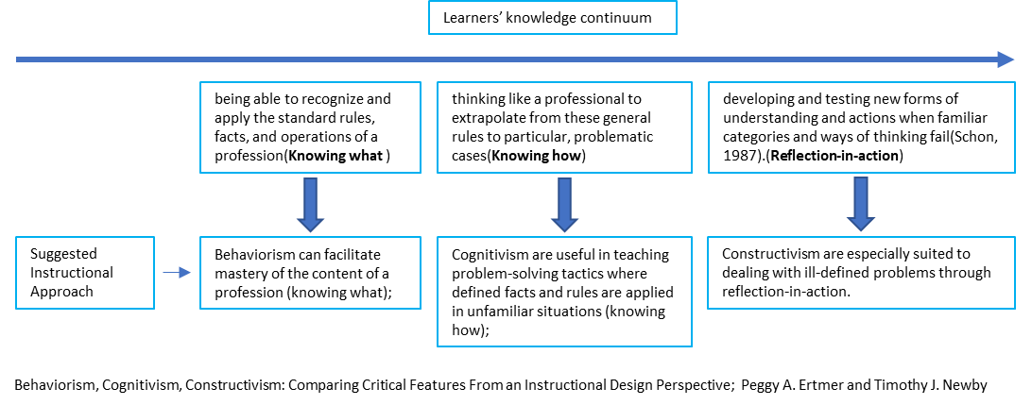

What Are the Implications for Instruction?
Theories attempt to explain various types of learning but differ in their ability to do so (Bruner, 1985). Behavioural theories emphasise the formation of associations between stimuli and responses through the selective reinforcement of correct responses. Behavioural theories seem best suited to explain simpler forms of learning that involve associations, such as multiplication facts, foreign language word meanings, and state capital cities.
Cognitive theories explain learning through factors such as information processing, memory networks, and student perceptions and interpretations of classroom factors (teachers, peers, materials, and organisation). Cognitive theories appear to be more appropriate for explaining complex forms of learning, such as solving mathematical word problems, drawing inferences from text, and writing essays.
Schunk, Dale H. Learning theories: an educational perspective / Dale H. Schunk.—6th ed. pp 47-48

System = Classroom = Instructor + learner + Environment
Environment: In the context of learning theories—Behaviourism, Cognitivism, and Constructivism—the term "environment" refers to different aspects of the learning context and how they influence the learning process. However, the meaning and role of the environment vary across these theories:
- Behaviourism: Meaning of Environment: The environment is everything external to the learner that can influence behaviour. It includes stimuli, rewards, punishments, and reinforcements.
  - Role in Learning: Learning is seen as a change in behaviour due to responses to environmental stimuli. The environment controls learning through conditioning (classical or operant).
  - Example: A teacher uses praise (positive reinforcement) to encourage students to participate in class. A teacher uses a reward chart: When a student answers a question correctly, they get a star sticker. After 5 stars, they get a prize. This external reinforcement shapes behaviour (participation, correct answers).
- Cognitivism: Meaning of Environment: The environment provides information and stimuli that the learner processes internally using cognitive functions like attention, memory, and problem-solving.
  - Role in Learning: The environment is important, but it plays a supporting role. The focus is on how learners interpret and process the information from their surroundings.
  - Example: A well-structured classroom with visual aids and organised content helps students encode and recall information effectively. A teacher presents a lesson using a PowerPoint with diagrams, flowcharts, and summaries. They use chunking to group related concepts, and question prompts to activate prior knowledge.

- Constructivism: Meaning of Environment: The environment includes the social, cultural, and physical context in which learning occurs. It is where learners actively construct knowledge through experiences and interactions.
  - Role in Learning: The environment is a dynamic space where learners engage in exploration, collaboration, and meaning-making. Learning is situated and influenced by context.
  - Example: In a project-based classroom, students work together to solve real-world problems, using the environment as a source of information and context for learning. Students work in groups on a science project about climate change. They research, discuss, visit a local site, and present findings. The teacher guides, but lets students explore and draw conclusions.

Comparative Chart: Roles in Learning Theories
Aspect | Behaviourism | Cognitivism | Constructivism
Role of Instructor | - Controller of stimuli and reinforcements  - Directs and shapes behaviour  - Provides structured tasks and rewards | - Organiser of content  - Facilitator of mental processing  - Provides clear explanations and cognitive strategies | - Guide and co-learner  - Facilitates exploration and inquiry  - Scaffold learning experiences
Role of Learner | - Passive recipient  - Responds to external stimuli  - Behaviours are conditioned and shaped | - Active processor  - Builds internal mental models  - Uses strategies like rehearsal, chunking, and schema-building | - Active constructor of knowledge  - Engages in self-directed inquiry  - Learns through interaction and reflection
Role of Environment | - Source of stimuli, cues, and reinforcement  - Structured to elicit desired behaviours | - Source of information  - Should be organised to support attention, memory, and understanding | - Context for social interaction and exploration  - Rich in resources and opportunities for meaning-making
Instructional Methods examples | - Drill and practice  - Repetition  - Reward and punishment (reinforcement)  - Direct instruction  - Behaviour modelling  - Programmed instruction  - Stimulus-response training  - Immediate correction | - Use of mnemonics  - Chunking of content  - Scaffolding  - Graphic organisers (e.g., concept maps, flowcharts)  - Advanced organisers  - Think-aloud strategies  - Feedback (informational)  - Goal-setting and guided questioning  - Metacognitive prompts | - Design thinking  - Project-based learning  - Inquiry-based learning  - Collaborative learning (peer discussion, group tasks)  - Experiential learning  - Problem-based learning  - Socratic questioning  - Learning by discovery  - Real-world tasks  - Reflection journals

Rules

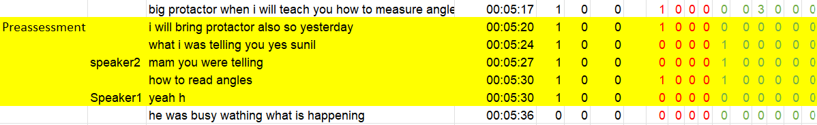

- When a teacher is introducing a new concept, if the teacher is teaching the concept by using various methods to connect new knowledge with previous knowledge (gradual teaching) and involves the students by asking “Understanding” related questions (active learner), then it creates the instance of Cognitivism. On the other hand, if the teacher is simply saying things from the definition and trying to teach them by examples (especially in Math) to change the behaviour of students, then it creates the instance of Behaviourism.

Science
- Some patterns were observed while analysing videos from science subjects
  - These classes occur in traditional settings where, generally, teachers who are concerned with making students understand concepts spend more time teaching by telling the meaning of concepts and asking students lots of elaborate types of questions so that students can link previous knowledge to new information. Since elaboration helps the brain impose structure on learning and assists in the consolidation of neural connections in memory, we classified these scenarios as Cognitivism. “Elaboration” can also be a part of discovery learning, which comes under Constructivism as mentioned above. But to call a sc
  - Some teachers are teaching science by just coming and writing on the blackboard whatever is given in books, like the entire derivation from the book, etc. They assume that by looking at the proof on the board, students will understand the proof and memorise it. This is very close to rote learning, and this teaching style is encoded as Behaviourism.

Math
- Some patterns were observed while analysing videos from math subject
  - Math classes are different from science classes on account of the fact that math involves more procedural knowledge. Hence teachers spent more time on solving examples rather than meaningful teaching.
  - Two distinct styles of teaching math were observed, as was the case for science classes
    - Teachers who are more concerned with teaching students the meaning of the topic spend more time asking students what the next step as will be opposed to teachers who are more concerned about just telling the procedural knowledge and generally explaining the topic without asking any questions to students and also while solving examples, they do it on board by themselves assuming students will listen and follow. We are calling the first approach cognitivist and the latter behaviourist.

    - Many of the instructional strategies advocated and utilised by cognitivists are also emphasised by behaviourists, yet usually for different reasons. An obvious commonality is the use of feedback. A behaviourist uses feedback (reinforcement) to modify behaviour in the desired direction, while cognitivists make use of feedback (knowledge of results) to guide and support accurate mental connections (Thompson, Simonson, & Hargrave, 1992).

    - Because of the above reason, when the teacher is solving math example problems while asking students about the next steps, it is not clear that he/she is using Behaviourist approaches (Chaining), or Cognitivist approaches to determine the mental connection. Hence, we are marking both Behaviourism and Cognitivism for these lines.

    - In case of M.K.(teacher), do we call it Cog or Beh+Cog?

    - In case of M.K.(students), do we call it Cog or Con+Cog or Con?

 | While doing | While Explaining
Teacher only | Beh | Beh
(initiate) Teacher to student | Cog + Beh | Cog
(initiate) Student to teacher | Cog | Cog
Students only | Con | Con

Class – 17/08/2022, Chemistry, 11th
Teaching Style- In this classroom, the teacher tries to teach the meaning of the topic (Molarity and Molality). The teacher is using the following methods to teach during the Preassesment and Teaching part of the episode
- Asking about the meaning of definitions
- Asking students to summarise the meaning of topics in their own words
- Giving real-life and hypothetical examples and analogies
- Connecting new information to prior knowledge

All these methodologies are indicative of Cognitivism being used while teaching. Hence, we have encoded these sections as Cognitivism
- In the Assessment part of the class, the teacher is dictating questions and asking factual questions. After teaching, giving questions where students have to feed the data to get the answer can be seen as creating an environment where stimulus–response association can be encouraged. This is suggestive of Behaviourism being used in the classroom. But sometimes, while doing an assessment, the teacher delineates and explains some conceptual knowledge. The teacher is trying to remind students about concepts that can be relevant to solving the problem and can be seen as connecting new information to prior knowledge. Because of these reasons, we are encoding those subparts of assessment as Cognitivism.
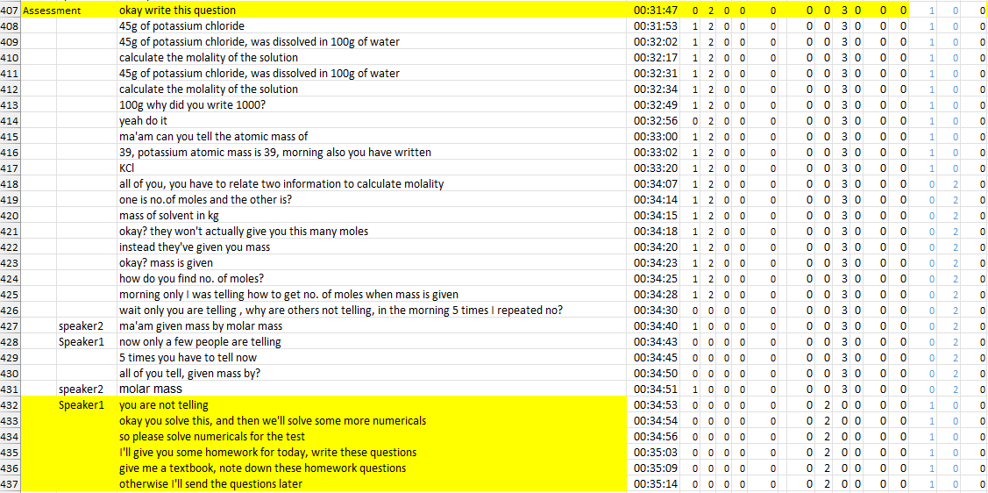
- Class – 17/08/2022, Chemistry, 11th


Class – 01/08/2022, Science, 6th
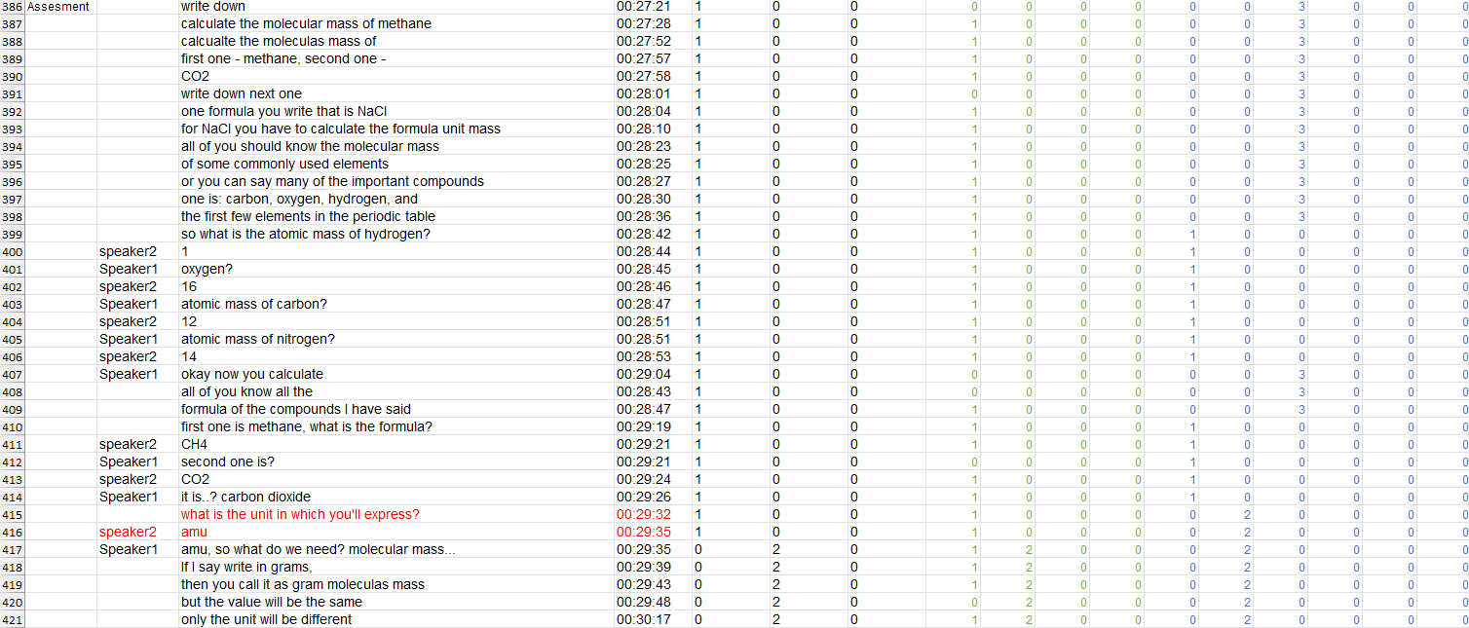
Class – 10/08/2022, Chemistry, 11th

Math
- Indicators of Behaviourism
  - “What” type of questions
- Indicators of Cognitivism
  - “Why” type of questions
    - Example- Why are you (Student) performing this step?
    - Reasoning- When the teacher is asking “Why” type of questions, she prompts students to Summarise, outline, etc., and also makes structure and mental connections
  - The teacher asks the student to come to the board and solve the problem

Table 2: Final Coding Scheme
- In case of a clash between the “Role of the Instructor” and the “Role of the learner” rows, priority should be given to the intention of the teacher, i.e. “Role of the Instructor” rows while doing encoding.
- Table 2 should be used in conjunction with the coding scheme provided in Fig 1. Table 2 coding scheme is derived from Schunk's book, and Fig 1 table has been taken from Ertmer et. al.'s paper.

 | Behaviorism | Cognitivism | Constructivism
Role of Instructor | Present learners with structured material (stimulus) and prompts for the right response  - Shaping and/or Chaining  - Mastery learning  - Programmed Instruction | Provide learners with the strategies that allow them to connect new knowledge to existing knowledge  - Organisation  - Rehearsal (F.K. + C.K.)  - Elaboration  - Advance Organisers (C.K. + P.K.)  - Attention  - Encoding  - Schema (M.K.) | Aids learners in exploring topics and coming to their own understanding by asking questions  - Discovery Learning  - Inquiry Teaching  - Peer-Assisted Learning  - Discussions and Debates
Role of Learner | Passive  - If students are just listening without asking questions or not getting engaged in the discussion by themselves or by the teacher, they only answer questions when asked. | Active  - If students are engaged in the discussion mentally in the classroom, either by themselves or because the teacher is promoting engagement | Active  - Students are engaged in discussion among group members and with other groups
Examples: Area of a triangle | The teacher tells the student the formula for the area of the triangle, i.e., ½*b*h.  Then gives the problem based on the formula, and then announces that whoever solves it first can go home early. | 1. The teacher recalls what a triangle is and its characteristics, such as its height, base length, etc.  2. The teacher creates a Mnemonic like Dead Monkey Smell Bad, etc.  3. Teacher prompts learners with a color-coded visual aid | 1. A mentor poses the topic as a problem: how the area of a triangle can be calculated.  2. The teacher divides the students into groups to come up with different strategies to find the general formula of the area of the triangle.

Rules (With global encoding)
It has been observed that finding out teachers' intentions helps a lot while encoding LT (learning theories). For this reason, examples are tabulated here for the three global encoding sections (Preassessment, Teaching, and Assessment).
- Preassessment
- In the preassessment section, teachers are generally trying to figure out students' knowledge level about the topic. This is generally initiated with a “What” type of question. This seems very close to the scheme given as “Preassessment of students to determine where instruction should begin [learner analysis]” from Fig. 1, which suggests these situations should be encoded as behaviourism. Also, many times, the teacher might start the class with general instructions like “Don’t shout,” or “sit down”, or “look at the blackboard”, etc. Since the instructions given by the teacher seem to be more related to the behaviour modulation of students, hence these scenarios should also be encoded as behaviourism. For example, from “20220801_130515_6A_Sci_Svs”, we can see the teacher is asking for every part of the leaf name, which has already been taught in the classroom. Hence, it is encoded as behaviourism. If a teacher had been showing the leaves in the classroom and teaching them, then that scenario would have been called as cognitivism (because he is using a visual aid to teach the students). However, in this class, the teacher's intention was to bring students to the ground and let them explore. But before he did that, he started by asking the ‘what’ type of questions (Name of the part of the leaves, etc.) to students to figure out if they remembered the previous class teaching. This is the reason this chunk is part of preassessment and, in turn, should be encoded as behaviourism

20220810_122224_chem_tr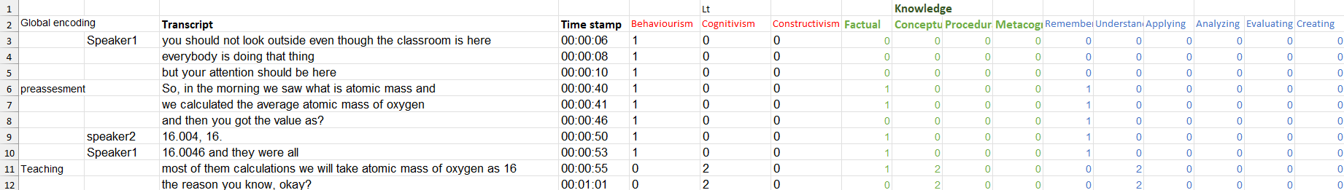

20220801_130515_6A_Sci_Svs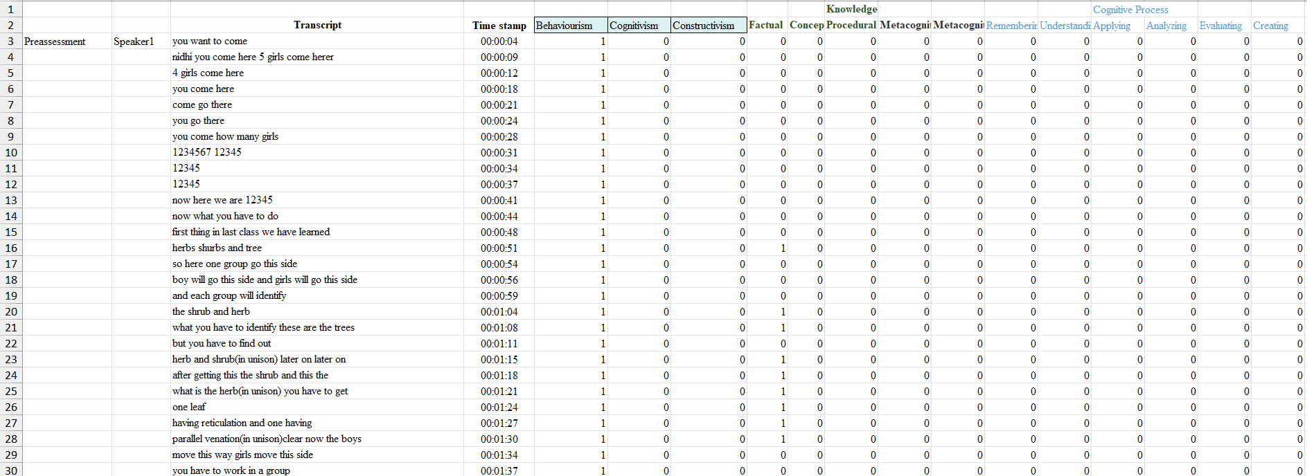

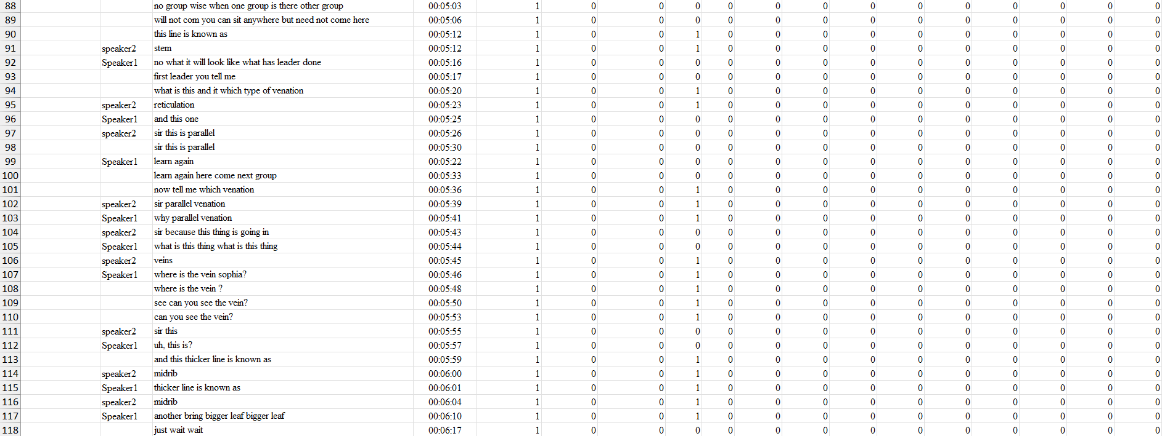
- Cognitivism might occur in preassessment in the scenario if the teacher delineates from asking “what” type of question to “why” type or meaningful questions (like, “Tell me the meaning of some term or understanding of a concept”). In these scenarios, generally, elaboration takes place, and hence, we are encoding these lines (3-37) as cognitivism, as shown below in 20220817_124545_11b_chem_tr. Also, in between the cognitivism chunks, if some behavioural instructions occur (for 2-3 lines), we have encoded those lines as behaviourism as well without breaking the chunk of cognitivism, but if the teacher delineates from teaching and starts to scold students or some off-topic instructions start occurring for longer chunks (more than 3 lines), then we need to break the chunk of cognitivism. Generally, this occurs while teaching, and in preassessment scenarios, it does not occur. Hence, lines 8-10 have been encoded as both behaviourism and cognitivism.
[Why Cognitivism
- The teacher is focusing on mental understanding of a conceptual term (“1 molar solution”).
- She's encouraging students to retrieve prior knowledge, explain it, and clarify misconceptions.
- She’s prompting deeper thinking (e.g., “Why am I saying one molar? What does it mean?”), not just a correct answer.
- She gives hints and scaffolds through dialogue (e.g., referring to prior numericals done).
Cognitivist learning is focused on internal processes like memory, comprehension, and mental structuring of information, which is what the teacher is guiding here.
Behaviourism reasoning: Teacher manages classroom discipline and attention ("why are you all talking...when she speaks, everyone has to listen").]

20220817_124545_11b_chem_tr
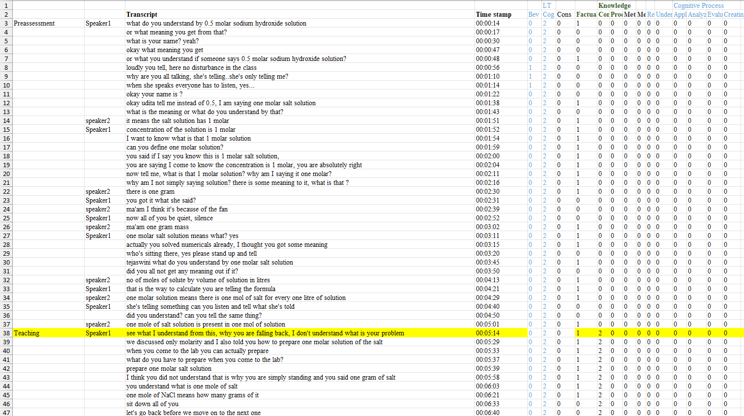
- Below is an example where cognitivism and constructivism both occurred during preassessment. Since, in one day, many activities were occurring, we have encoded these excerpts as both cognitivist and constructivist. [Vignette_Sci_7]
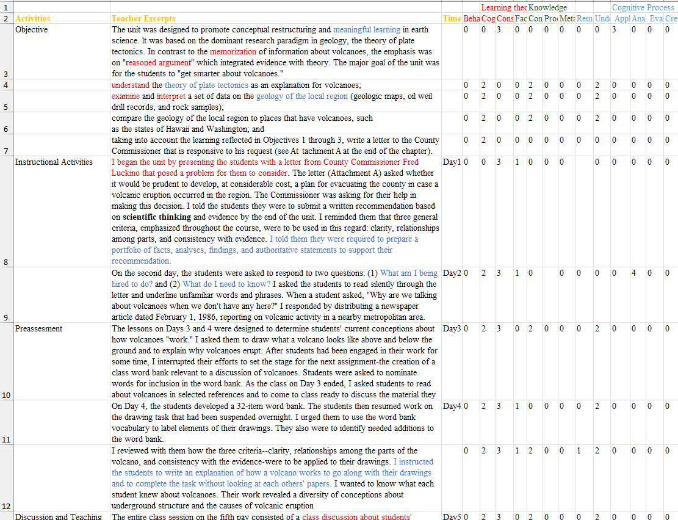

- Teaching
- In teaching global encoding scenarios, generally, the teacher introduces conceptual knowledge, procedural knowledge, etc. However, it depends on the teacher’s style of teaching and how they are introducing a concept or procedure, which will ultimately decide the learning theories we are trying to encode. Looking at global encoding provides us with a bearing on where to switch while encoding. For example, if the teacher was asking “what” type of question in the preassessment section to figure out where students' current knowledge resides and after that, they start teaching a new topic by using organisation, rehearsal (F.K.+ C.K.), elaboration, advance organisers (C.K. + P.K.), attention, encoding and schema (M.K.) etc. then the switch from behaviourism to cognitivism can be pointed out by using global encoding switch. Examples are provided, which show in “teaching” that all types of LT can occur, and it ultimately depends on the teacher’s style of teaching.
- In the example below (20220817_105612_12b_phy_mg), the teacher is teaching by deriving the formula on the blackboard without teaching the meaning of the topic. Also, Students are passively listening. The intention of the teacher is to show the students the derivation so that when this question is asked, they can derive it. Hence, the encoding is behaviourism.

20220817_105612_12b_phy_mg
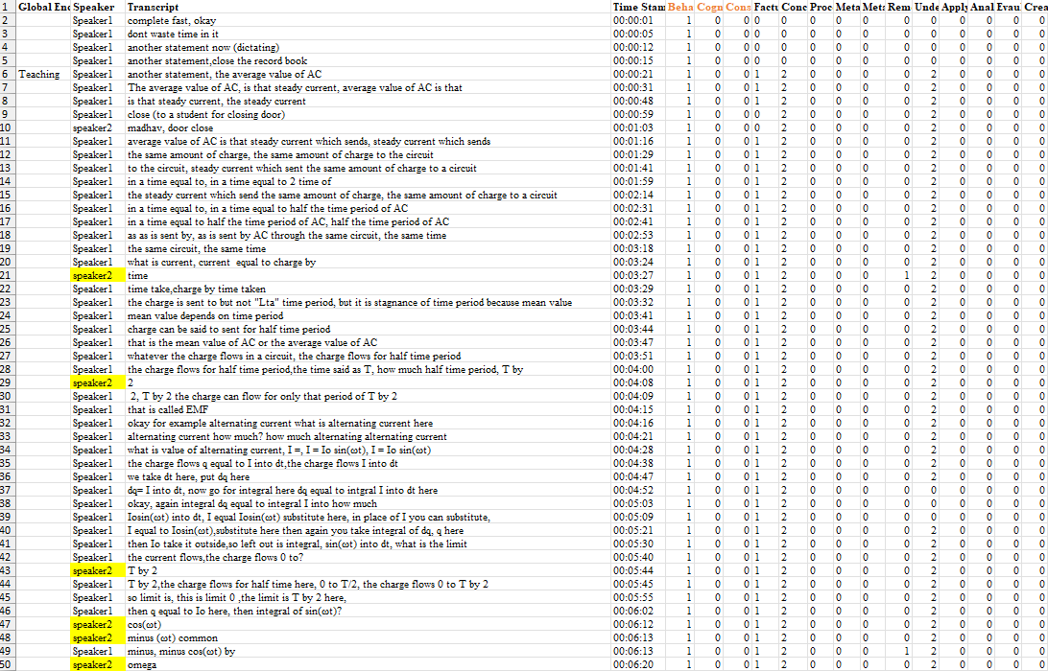
- Below example (17_08_math_12a) is a little bit subtle. By watching the video, it can be concluded that although teachers draw figures of increasing function to explain the use of derivatives in increasing function determination, it still will be encoded as behaviourism because teacher style does not involve any strategies like organisation, rehearsal (F.K.+ C.K.), elaboration, advance organisers (C.K. + P.K.), attention, encoding and schema (M.K.) etc. Also, Students are passively listening; hence, encoding is leaning towards more behaviourism rather than cognitivism. These types of judgments are pretty apparent after watching videos. For lines 54-61, the teacher asks a question which involves students to apply conceptual knowledge. Since this question was not straightforward from what the teacher is teaching, and it requires students to apply knowledge in a relatively new scenario which was not discussed separately, this scenario cannot be called shaping or chaining, and hence this type of interaction is encoded as cognitivism and not behaviourism. A point to note is that since this was a very small chunk, we have encoded these lines as both cognitivism and behaviourism without breaking the behaviourism chunk.
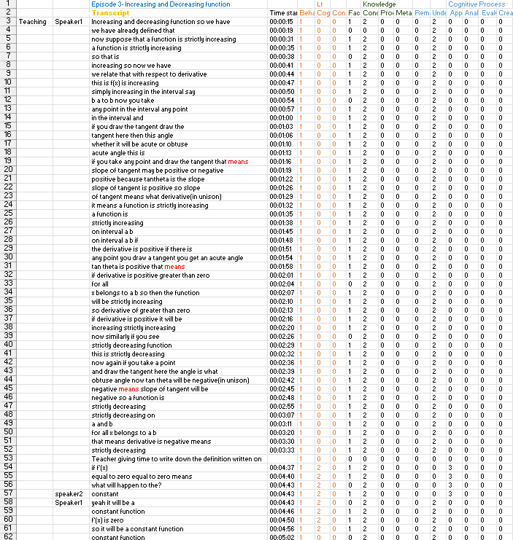
17_08_math_12a

- In the below example (20220721_124928svs_10a_sci), initial lines have been encoded as behaviourism (1-3). After that, the teacher asked a question by writing something wrong (lines 8-10) on the board (which is apparent by watching the video). Students were picking on this point and correcting him. This is a type of strategy teachers use to grab the attention of the students and can be classified as a kind of rehearsal. After that, the teacher started asking a series of questions by giving students choices which required the students to use the understanding cognitive process dimension, which in turn is very close to the elaboration and hence should be encoded as cognitivism. However, one might argue these are examples of Shaping and or Chaining, which makes this whole conversation (lines 6 to 18) behaviourist. Since we are unable to decide emphatically, we are encoding these lines as both behaviourist and cognitivist. This type of scenarios occurs very rarely, but when they do, we have to acknowledge them. However, because of the rarity of these types of situations, statistically speaking, this should not affect our result drastically. Similar arguments are used to encode lines 284 to 288.
20220721_124928svs_10a_sci
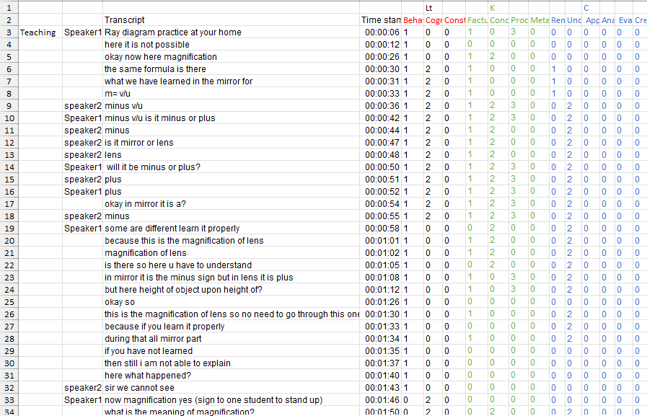


- Below are some of the examples with only cognitivism

20220817_124545_11b_chem_tr
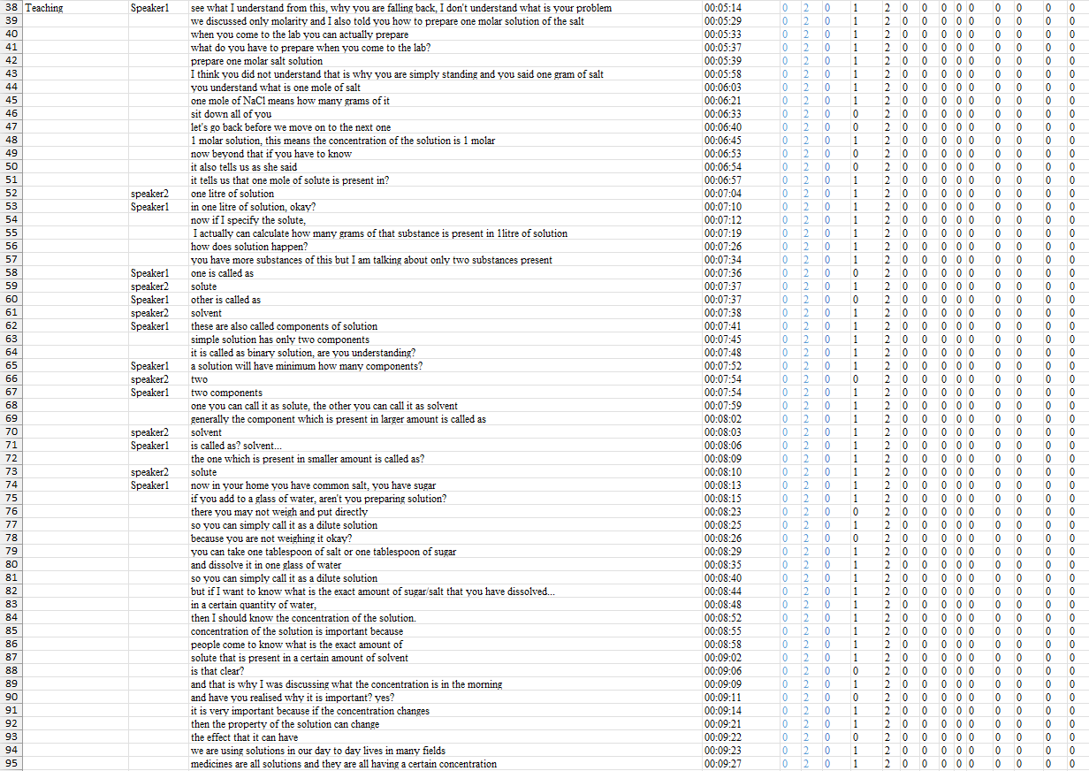
20220801_130515_6A_Sci_Svs
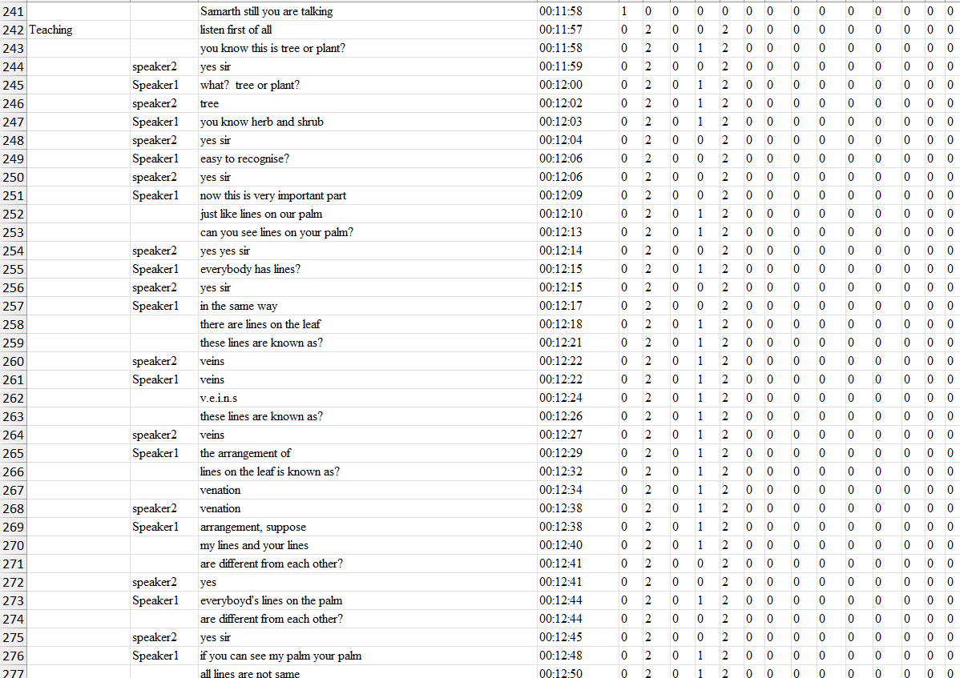
20220729_093414ah_10a_math1
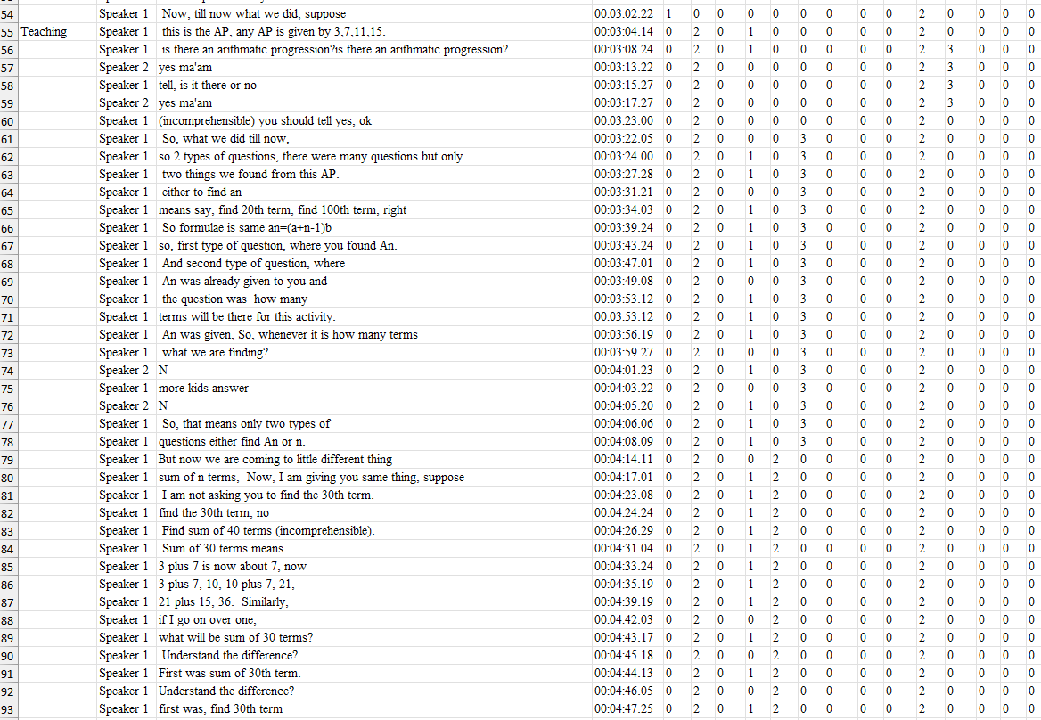

- Below is an example where cognitivism and constructivism both occurred during preassessment. Since, in one day, many activities were occurring, we have encoded these excerpts as both cognitivist and constructivist.
Vignette_Sci_7
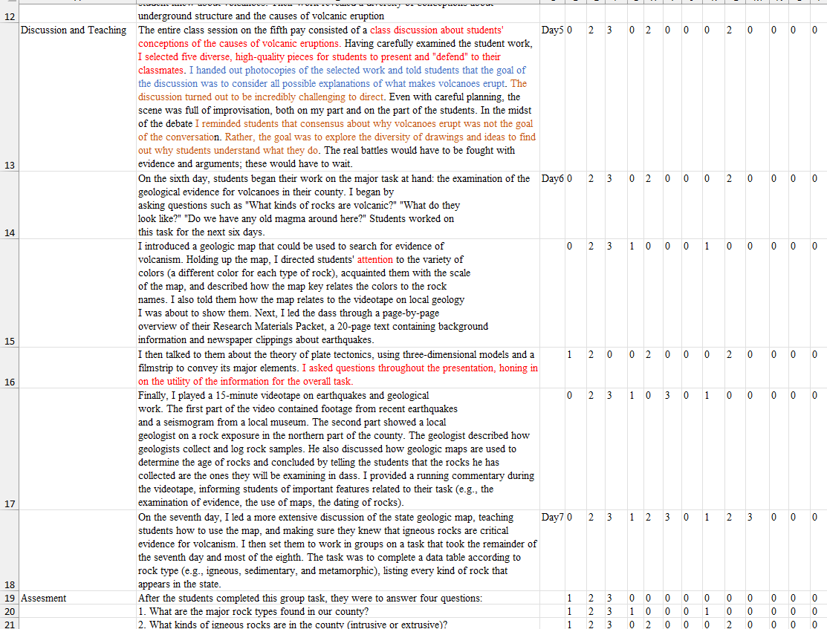

- Assessment
- In the assessment section, generally, the teacher gives questions related to what they have taught. Hence, generally, behaviourism is favoured for encoding. Below are some examples where only behaviourism occurred.

20220729_093414ah_10a_math1
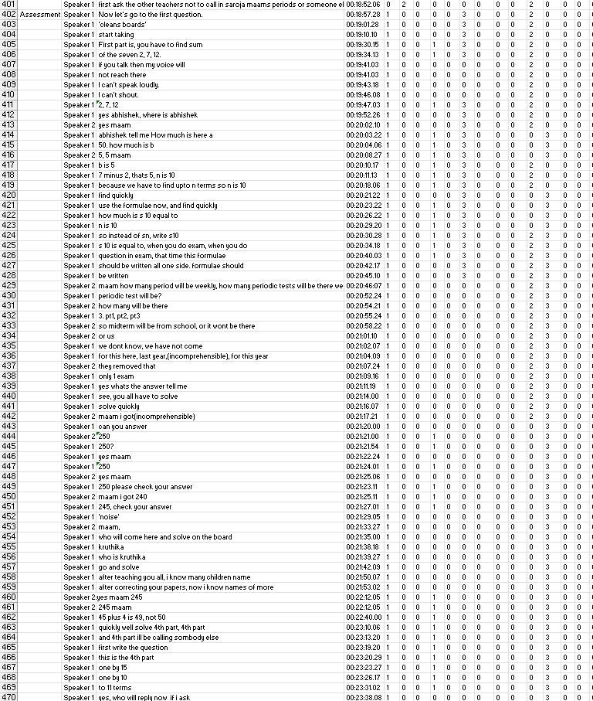

20220721_124928svs_10a_sci
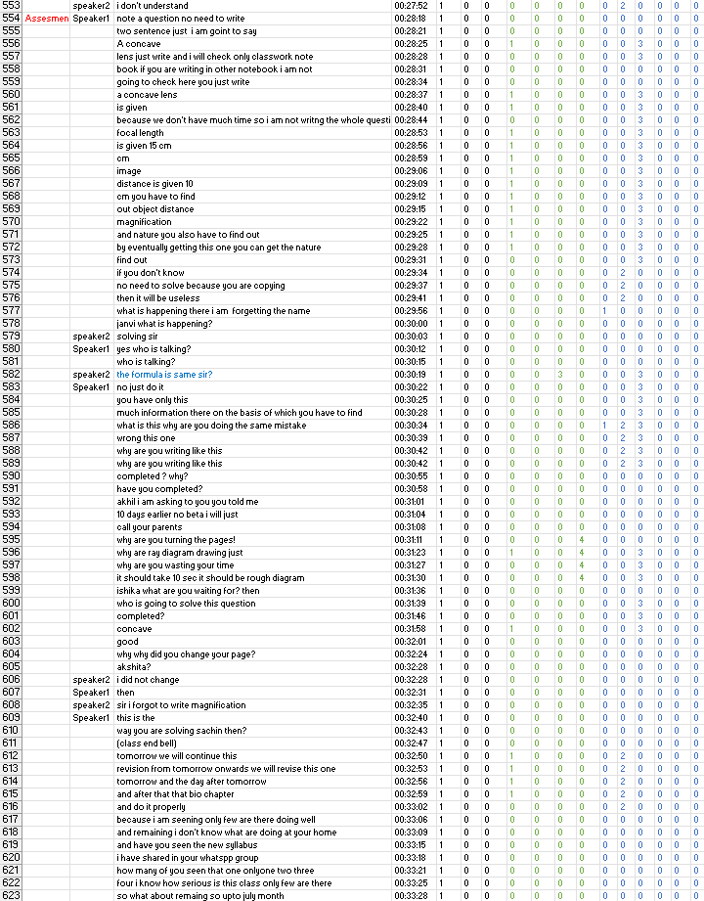

17_08_math_12a_jkp
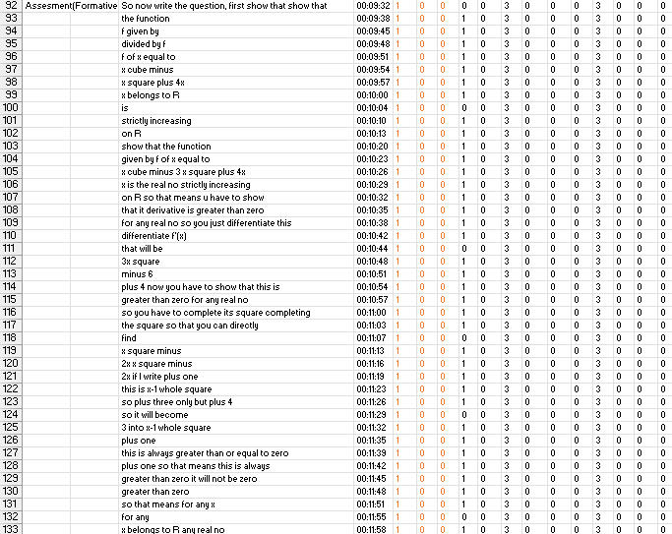

- In the assessment section, generally, the teacher gives questions related to what they have taught. However, in some scenarios, cognitivism and constructivism will also occur. In the example (20220817_124545_11b_chem_tr) shown below, from lines 407 to 417, the teacher was dictating the question; hence, it has been encoded as behaviourism. After that, for lines 418 to 431, the teacher started to tell students the conceptual knowledge that can be used to solve the problem. This suggests that the teacher was not providing a solution to the problem. Rather, she was telling students concepts/strategies to solve the problem, which suggests she is making students more active by connecting previous knowledge and making students solve the problem by themselves. Because of these reasons, these lines have been encoded as cognitivism.

20220817_124545_11b_chem_tr
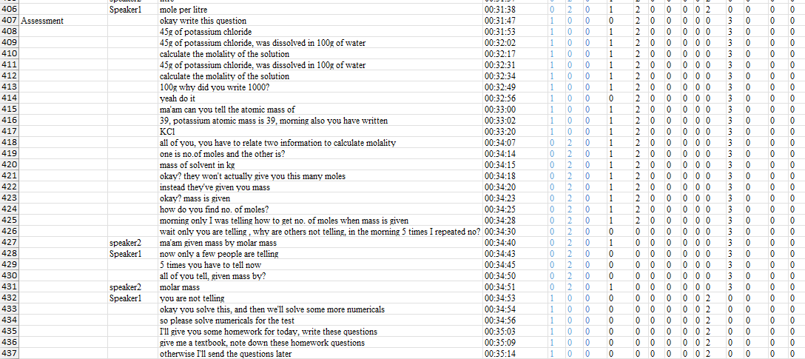

- In the below example (20220801_130515_6A_Sci_Svs), as explained in previous points, lines 483-502 have been encoded as behaviourism, but in lines 503-530, the teacher delineated from the original topic and started asking questions from different topics related to plants. Since he is promoting elaboration here by connecting previous information to this topic, it has been encoded as cognitivism. A point to note here is that the teacher is asking a ‘why’ type of question to bring elaboration into the picture rather than asking a ‘what’ type of question, and hence, it has been encoded as cognitivism.

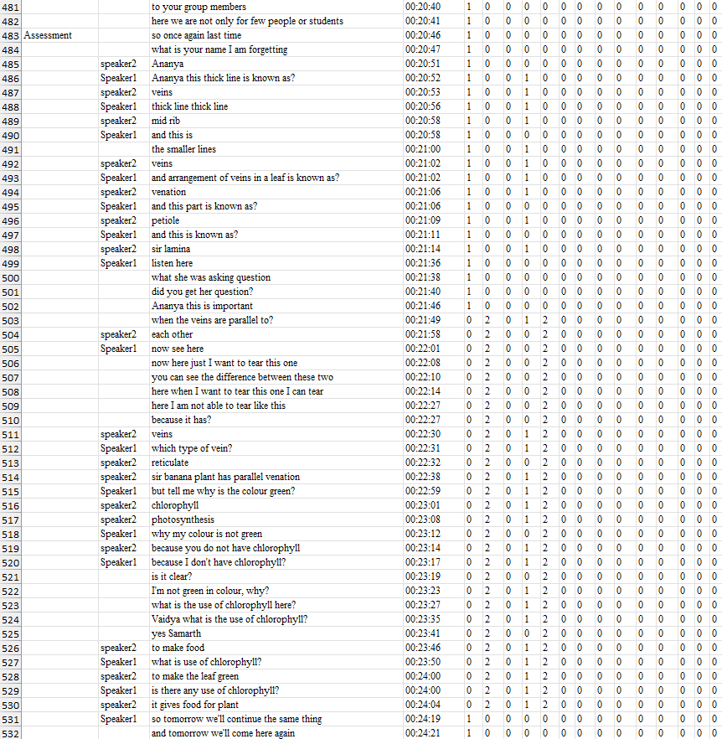

- Again, in this example (20220810_122224_chem_tr), all assessment line was behaviourist until the last lines 417-421, where the teacher elaborates to teach conceptual knowledge. However, this is a very small chunk; hence, it is left up to the encoder’s discretion whether they want to break the chunk or keep the chunk of behaviourism.

20220810_122224_chem_tr
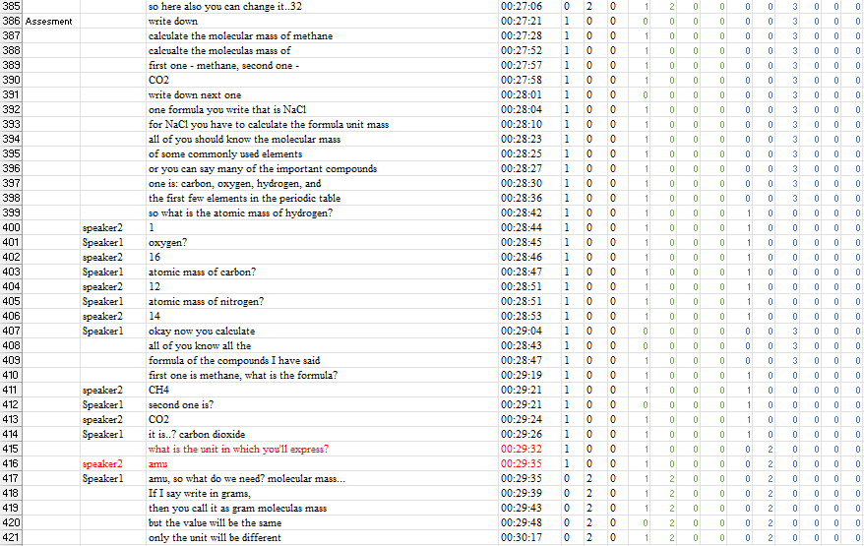

- Below are some examples where constructivism comes into the picture in the case of assessment global encoding
Vignette_Sci_7
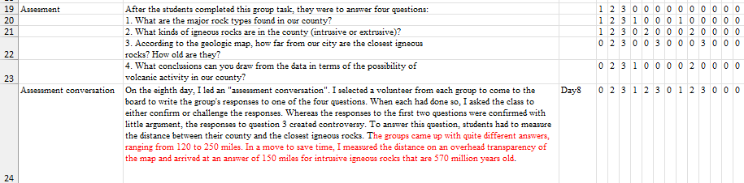


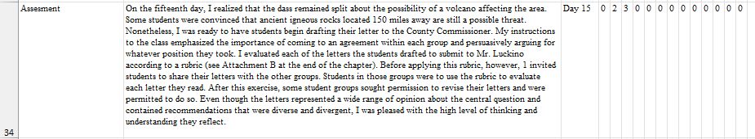

- Miscellaneous
- In Fig. 1 from Principles of Instructional Design for Cognitivism, the first point mentions that “An Emphasis on the active involvement of the learner in the learning process [learner control, metacognitive training (e.g., self-planning, monitoring, and revising techniques)]”. According to Anderson et al., metacognitive knowledge is knowledge of cognition in general, as well as awareness and knowledge of one's own cognition. This knowledge involves strategic knowledge and knowledge about cognitive tasks, including appropriate contextual and conditional knowledge and self-knowledge. Hence, it can be assumed that the above-mentioned principle and definition given by Anderson et al. are very close. Although measurement of MK is very hard because it is highly personal knowledge and varies from student to student, while doing the encoding of MK, it was assumed that if the teacher is promoting MK or sharing some general strategy, students must be learning that from them, and hence, MK is occurring in the class. On very rare occasions, teachers ask students to share their MK. In any scenario where the teacher is asking a student to share their MK or the teacher is sharing some MK by their experience, in both cases, it can be said that the teacher is following the first principle (metacognitive training), and hence, generally, the lines which are encoded as MK should be encoded as cognitivism as well.
20220810_122224_chem_tr
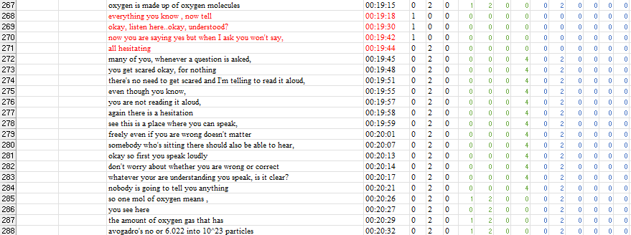

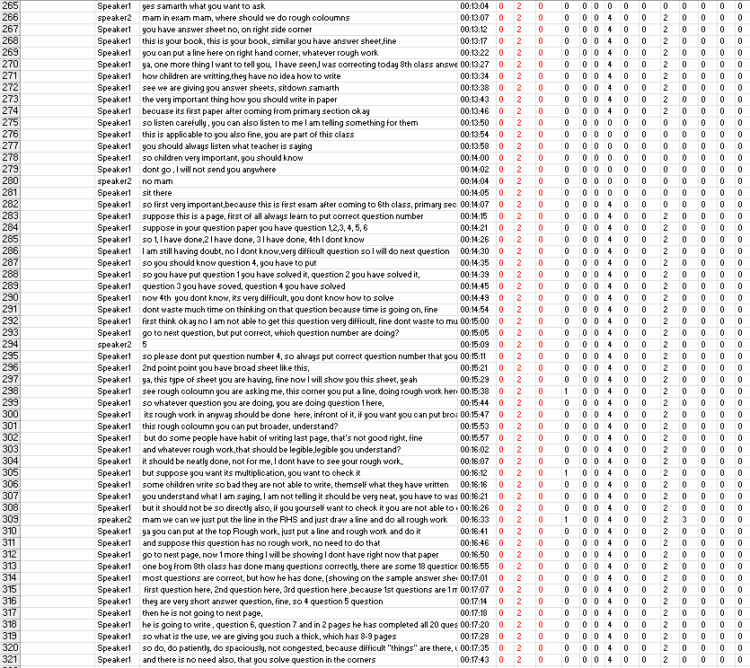
20220726_133023ah_6a_Maths

- It was observed that generally, in revision classes, if the intention of the teacher is to do elaboration or rehearsal, then these classes should be encoded as cognitivism. For example, in the whole class of 20220726_133023ah_6a_Maths, the teacher was trying to do rehearsal and elaboration, and hence, this class is mostly encoded as cognitivism.

S No. | Method | Theory | Justification
 |  | Behaviourism | Ensures focused engagement and maintains attention
  Classroom control and structured talk
 | Immediate correction/reinforcement | Behaviourism | Corrects misconceptions, reinforces right responses
 | Dictation of definitions/formula/derivation, Formula derivation without explanation, Recall prompts (e.g., "T/2"), Discipline-focused instructions | Behaviourism | Deliver content to be memorised, reinforce procedural recall, not understanding, Cue-response pattern (stimulus → answer), Ensure control and compliance
 |  |  | Reinforces correct associations with cues
  Call-and-response (e.g., “angle?” “obtuse”)
  Behaviourism
 |  | Behaviourism
  Note-taking time
  Reinforces retention through repetition and writing
 |  | Behaviourism
  Verbal questioning (e.g., “What’s the answer?”)
  Triggers rote recall (stimulus–response)
 |  |  | Reinforces through public demonstration (positive reinforcement)
  Peer solving on the board
  Behaviourism (mild)
 |  |  | Strengthens procedural fluency through repetition
  Formula recall and application
  Behaviourism / Cognitivism
 |  |  | Promotes retrieval, comprehension, and schema building
  Questioning for recall and reasoning
  Cognitivism
 |  | Cognitivism | Encourages deeper cognitive engagement and understanding
  Prompting deeper meaning (why 1 molar?)
 |  | Cognitivism | Helps students build mental models of function behaviour
  Visual representation (graphs, tangents)
 |  | Cognitivism | Supports conceptual understanding and schema development
  Linking derivative sign to slope
 |  | Cognitivism | Uses prior mental model to solve new problems
  Application of previously taught formula

Type of rules | Behaviourism (Beh) | Cognitivism (Cog) | Constructivism (Con)
Decision rules | Code as Behaviourism when instruction emphasises observable behaviours, measurable outcomes, stimulus–response associations, and reinforcement-driven learning. | Code as Cognitivism when instruction targets internal cognitive processes involved in information processing, organisation, and regulation of learning. | Code as Constructivism when learning emphasises meaning-making through context-rich tasks, learner control, and application of knowledge beyond given information.
Inclusion criteria | - Instructions for the behaviour modulation of students  - “What” type of question for recalling  - Deriving the formula on the blackboard without teaching the meaning | - Using real-life models or pictures, etc., as a teaching aid  - “Why” type or meaningful questions while elaboration takes place  - Writing something wrong on the board for attention  - Asking a series of questions by giving students choices  - Connecting new information to prior knowledge  - Giving real-life and hypothetical examples and analogies | - Posing the topics as a problem, promoting meaningful learning  - Group activities with very little interference from the mentor
Exclusion criteria | - Lines encoded as MK  - Focus on internal mental processes, metacognitive strategies, learner reflection, or meaning making without observable performance emphasis | Only repetition without attention to understanding or strategy use | Highly structured instruction with predefined pathways and outcomes; emphasis on recall, explanation, or procedural execution without contextualization.
Boundary conditions | Drawing pictures without using any strategies to teach is encoded as Beh | - Questions requiring application of conceptual knowledge in a novel context are coded as Cog rather than Beh  - Asking a series of questions by giving students choices encoded as both Beh and Cog  - Repetition with visual aid encoded as both Beh and Cog | - Scenarios in which teachers divide students into groups for learning collaboratively and using behaviour modulation strategies encoded as both Con and Beh

